# Cell death quantification User Guide

Cell death quantification macro was developed for image J software.  
Authors: Jose Salguero-Linares, Saul Lema Asqui, Marta Salas-Gómez, Andrea Froilán-Soáres and Núria Sánchez-Coll.

# Image acquisition

Leica Microscope was used for imaging, however, scanner is also sutiable for this experiment. Resolution of 300 dpi was found to be sufficient, be we recommend at least 600 dpi resolution. This method work for all image files as TIFF or JPG.

# Macro installation

1. In the ImageJ toolbar, Plugins > Macros > Install > Select Cell death quantification.ijm
2. Now you can find the command buttons in the menu ( as shown in the image)

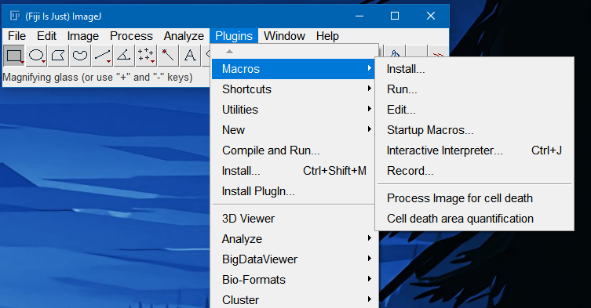

# Run the macro

1. Open your image containing your leaf.
2. Locate and select the **Process Image for cell death (Plugins-> Macros)** command, then run it.
3. You will be given the chance to crop your image if needed
   * To crop, select relevant area then press Ctrl + Shift + X
4. Your image will now be processed to facilitate cell death quantification.
5. Adjust the threshold according to your trypan blue image.

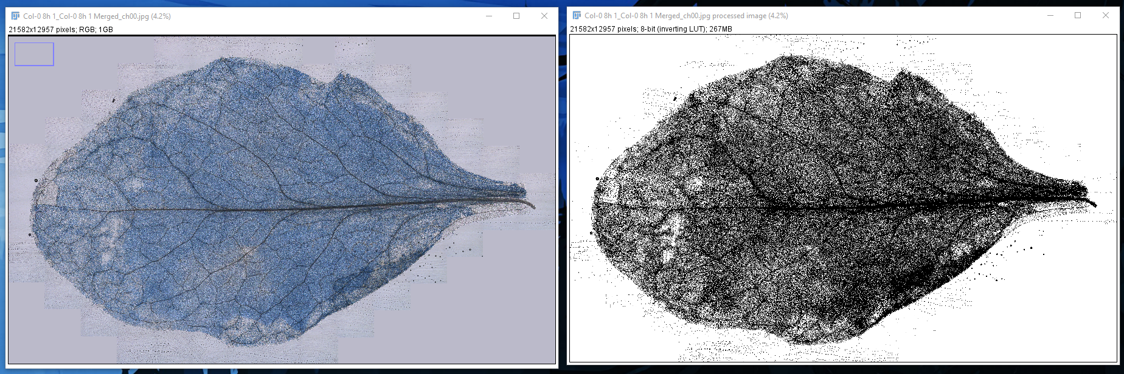

1. Then locate and select the **Cell death area quantification** **(Plugins -> Macros)** command, then run it.
2. Select the area of interest when prompted.
3. Automatically the selected area will be calculated.
4. The quantified area will be printed into your Log window. **Do not close this window until you are done!!!**
5. When area quantification is complete, save the Log file ( or copy the values in an excel file).